to continue reading. Thank you.

</p>

</div>

6. That is it. Now try to follow to the non-existing URL and see our content from the error-404.php view:

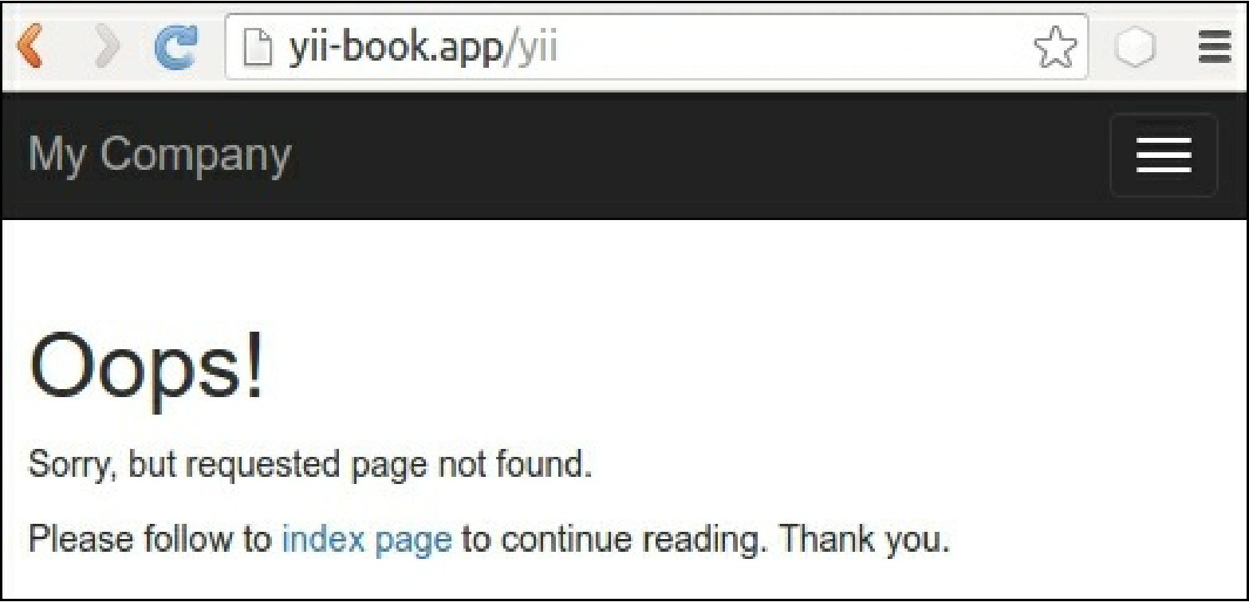

7. However, for a fail action we must see the default content from the error.php file:

